Part Ⅱ Problems-1 Test Oracle
- Test Oracle: a decision procedure on the program output of a test wrong, that makes a pass/fail decision about the test outcome.
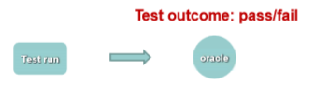
- A test case is as good as its oracle.
- Partial oracle: oracles may exist for a limited subset of the input domain, and detect only a limited subset of output errors.
- Practical test oracle:
- Specification as test oracle:
- Extract valid input/output pairs from specifications to verify ‘intended behavior’ of the system.
- Problem:
- The output may be too complex or not human-readable.
- The specification may be incomplete or ambiguous.
- The program may be un-deterministic(例如足球赛的结果预测程序).
- Reference implementation as test oracle:
- Reference implementation: another program that does exactly(or similarity) what the program under test does.
- Situation where such method can be available:
- Deliberately built to mimic the behavior of the program under test.
- There exist alternative products with minor implementation difference.
- The product has its own historical version.
- Typically during regression testing-use capture and replay tool interactions with the system under test and the captured output serves as test oracle for later version.
- During the replay of events, the possibilities of output checking:
- manual: user has to watch the system for anomalies
-complete: all output were recorded during capture, and system must reproduce them exactly
-checkpoints: system output is only checked at certain points for specified values.
- Program assertion as test oracle:
- Assertion: a statement in the program containing Boolean expression that believed to be true when the assertion executes.
- What to assert:
- Internal invariant: a fact you believe to be true at a certain point in the program.
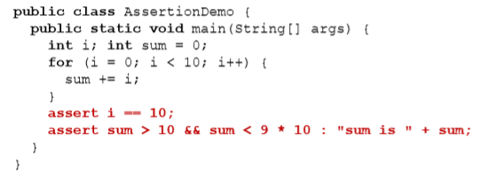
- Cases of conditional statements: assert the condition for the ‘default’ and ‘else’ branch.
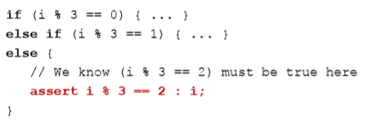
- Control flow invariant: if a program should never reach a point, then a constant false assertion may be used.
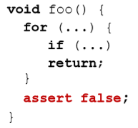
- Loop invariant:
- Initialization: condition that is true before first iteration.
- Maintenance: if it is true before an iteration, then it remains true before the next iteration.
- Termination: when loop terminates, the invariant gives a useful property to show the correctness of the algorithm.
- Assertion vs. Exception
- An exception tells the user of your program that something went wrong.
- An assertion tells you that you have a bug.
- When to throw exceptions:
- Test whether the parameters to a public method or public constructor are legal.
- Do any input/output.
- In short, anything that could go wrong, that you have no control over within this class, deserves an exception.
- Metamorphic property as test oracle:
- Many programs have properties such that certain changes to the input yield predictable changes to the output.
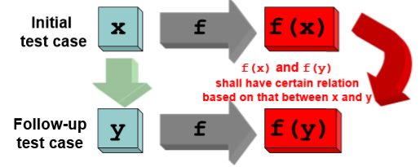
- It is very easy to detect defects in these programs by looking for any violations of these metamorphic properties.
- Categories of metamorphic properties:
- Additive: increase(or decrease) numerical values by a constant.
- Multiplicative: multiply numerical values by a constant.
- Permutative: randomly permute the order of elements in a set.
- Invertive: reverse the order of the elements in a set.
- Inclusive: add a new element to a set.
- Exclusive: remove an element from a set.
- Execution profiling as test oracle:
Execution profilers use instrumentation or sampling to monitor and record program execution details.
- How many statements have been executed
- Time elapsed in each function and its descandants
- How many amounts of memory are allocated/released
- How many variables have been read/written
- Heuristic and statistical test oracle:
- An intuitive solution to identify failed test runs:
- Learning the norms
- Identifying the outliers
- A more radical idea: directly use visualization technique to expose outliers.
- Use contracts as advanced assertion:
- Pre-condition: a condition that must always be true just prior to the execution of a method.
- Post-condition: a condition that must always be true just after the execution of a method.
- Class invariant: a condition that must always be true after the execution of any method of a class.
- A class invariant is an assertion that holds for all instances(objects) of the class.
- It must be satisfied after creation of every instance of the class.
- It must be preserved by every method of the class.
- E.g: a class invariant for a binary tree: for every node N in the tree, if its left child node N’ exists, then N>=N’. If its right child node N’’ exists, then N<N’’.
- Contract:
- Contract is the agreement between the client and the supplier.
- Client: requests a service.
- Supplier: supplies the service.
- No hidden clauses rule: no requirement other than the obligations written in the contract can be imposed on a party to obtain the benefits.

Part Ⅱ Problems-2 Test Adequacy
- Ways to understand test adequacy:
- Design rules to highlight inadequacy
- Obligation of the tester
- Indicator to test progress
- Practical test adequacy criteria
- Whitebox:
- Control-flow coverage: addresses the coverage of execution or control paths
- Logic coverage
- Data-flow coverage: addresses the coverage of interactions among data items
- Interface coverage
- Mutant coverage
- Blackbox
- Control flow graph:
- Node: each node represents an unit of processing.
- Entry/Exit node: entry node is where the function starts and exit node is where the function returns.
- Decision node: a node associated with multiple out-edges, also called a branching node.
Notes: all decision nodes are required to be side-effect free.
- Merge node: a node associated with multiple in-edges.
- Computation node: a node that is neither decision nor merge node.
- Edge: each edge(line between nodes x and y) represents the execute-after relation between node x and node y.
- Out-edge: a directed edge that originates from a node.
- In-edge: a directed link that ends up in a node.
- Control flow coverage
- Statement coverage
- Concerns the coverage of every executable statements.
- Cover all decision and computation nodes in CFG.
- Insensitive to the logical operators(|| and &&) in the decision node.
- Does not consider declarative or unreachable statements.
- The weakest among all control flow coverage.
- Basic block coverage
- A basic block is a maximal sequence of statements having the following properties:
- （单入口）Can only be entered through the first statement.
- （单出口）Can only exit through the last statement.
- （顺序执行）Whenever the first statement is executed, the remaining statements are executed in the given sequential order.
- Identify basic blocks in CFG:
- The first node in the CFG is a block entry.
- Any node that is directly reached by a decision node is a block entry.
- Any node that is directly reached by a merge node is a block entry.
- For each block entry, its basic block contains all the following nodes up to, but not including, the next entry code or the exit node of the CFG.
- Branch coverage(decision coverage)
- Concerns the coverage of all feasible edges coming out of the decision control.
- Branch coverage vs. Statement coverage
Branch coverage subsumes（把...归入） statement coverage.
- Loop coverage
- A loop has 2 main components:
- Loop body: statements that is executed repeatedly
- Control statement: determine whether if the loop body should be executed and thus serve as entry and exit criteria.
- Loop coverage concerns the repetition count of the loop body execution, including 5 situations:
- Bypass the loop (never enter the loop)
- Enter the loop once
- Enter the loop more than once
- Enter the loop max-1 times
- Enter the loop max times
- The case of nested loop:
- If we use the 5 possible test cases for a loop structure as a guideline, then 2 nested loops would need 4*5 test cases.
- In general, this would be still be big for multiple nested loops: O(5^{n}) for n-nested loops.
- All path coverage
- Concerns the coverage of every feasible path in the CFG.
- Linearly independent paths: among a set of paths, if none of them can be constructed as a “linear combination” of the other paths.
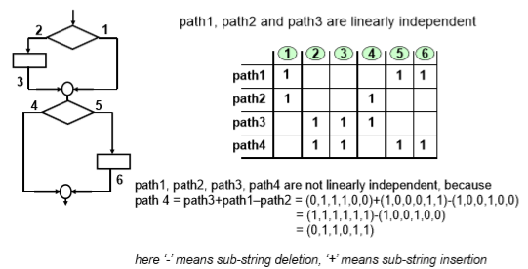
- Basis path set: a set of linearly independent paths is said to be a basis path set for a CFG, if any path in the CFG can be constructed as a linear combination of these paths.
- Basic path coverage
- Concern the coverage of basis path set.
- It might be sufficient to test basis path set only instead of all possible paths, since the other path can be constructed as their linear combination.
- Cyclomatic complexity（圈复杂度）： the size of basis path set in the CFG.
- # of binary decisions + 1
- # of edges - # of nodes + 2
- Subsumption relation: coverage criterion A subsumes coverage criterion B if test suite that satisfies A at the same time satisfies B.
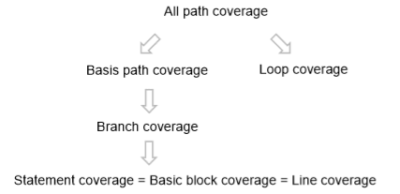
- Logic coverage
- Definitions: condition and decision
- Decision: branching expressing of the if/while/for statements
- Condition: a Boolean expression containing no Boolean operators(||, &&, !). E.g: a>b.
- Logic coverage includes:
- Decision coverage (i.e. Branch coverage)
- Condition coverage （条件覆盖）
- Short-circuiting condition coverage （短路求值语义下的条件覆盖）
- Condition/decision coverage （条件判定覆盖）
- Multiple-condition coverage （条件组合覆盖）
- Modified condition/decision coverage(MC/DC) （修改的条件判定覆盖）
- Logic coverage
- Condition coverage:
- Concerns the coverage of each condition talking about true and false.
- Does not consider constant condition, such as (true) and (x==x).
- Does not consider short-circuiting.
- Condition coverage does not subsume decision coverage.
- The number of test cases to achieve 100% condition coverage is always 2.
- Condition/decision coverage -- simply condition coverage + decision coverage
- For each condition, the test suite covers both true and false.
- For the whole decision, the test suite covers both true and false.
- Short-circuiting condition coverage:
- The same with condition coverage, except that we now require each condition being actually evaluated to true and false.
- Short-circuiting condition coverage subsumes decision coverage.
- There must be a condition that is evaluated last in the graph.
- If it is evaluated, it must not have been short-circuited.
- And it must be evaluated to true or false.
- Finding short-circuiting condition adequate test cases:
- Transform the complex decision into condition graph.
- Checking short-circuiting condition coverage => checking whether all edges in the condition graph are covered.
- Modified condition/decision coverage
- MC/DC requires that for each condition, both its evaluation true and false are shown to determine the outcome of the decision.
- The outcome of a decision changes as a result of changing a single condition.
- For each condition C, select two cases such that the truth values of all the conditions, except for C, are the same, and the decision outcome evaluates to be true for one and false for the other.
- Finding MC/DC adequate test cases:
- Create truth table for conditions.
- Extend truth table so that it indicate which test cases can be used to satisfy MC/DC for each condition.
- Comments on MC/DC
- Linear growth in required tests: for an expression with N uncoupled conditions, MC/DC can be satisfied by a minimum of N+1 test cases and a maximum 2N test cases.
- Ensures a much higher level of coverage than branch or condition coverage.
- Coupled conditions: B is coupled to A when changing B will also affect A. E.g. x>0 && x>=0.
- Multiple condition coverage
- Cover all possible combinations of conditions.
- If decision D has k uncoupled conditions, the total number of combinations 2^{k}.
- This method is not practical expression with a large number of conditions.s
- Subsumption relation of logic coverage
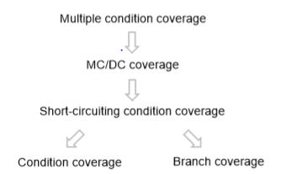
- Data-flow occurs from where a variable is defined to where it is used, without any intervening re-definitions.
- Operations on variables:
- Definition: a value is written into a variable.
- Use: the value of the variable is read.
- Undefinition: a variable is not longer accessible.
- Two types of use:
- Computation use(c-use): the value of the variable directly affects a computation or is part of an output.
- Predicate use(p-use): the value of the variable directly affects a control flow (and may indirectly affect a computation).
- Def-clear path: a definition clear path with respect to x(def-clear path wrt x) is a path(i, n₁,n₂, n₃,...,n_{m}, j)where m>=0, containing no def(x) or undef(x) in nodes n₁, n₂,...,n_{m}.
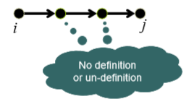
- Simple path: a path in which all nodes, except possibly the fist and last, are distinct.
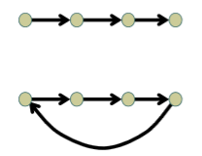
- Loop-free path: a simple path in which all nodes are distinct.
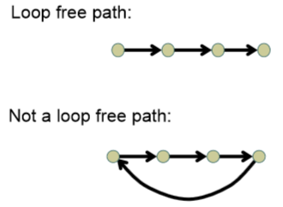
- Du-path: a path is a du-path for variable x if n1 define x and
- Either n_{k} has a c-use of x and (n₁, n₂, n₃,..., n_{k}) is a def-clear simple path with respect to x.
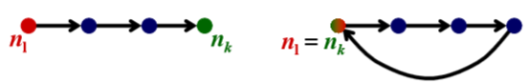
- Or n_{k} has a p-use of x and (n₁, n₂, n₃,..., n_{k}) is a def-clear path with respect to x.
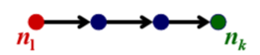
- Dataflow coverage
- All-defs coverage: For each node i that contains a definition to variable x, it requires the test suite covers at least one feasible du-path of x that start from i.
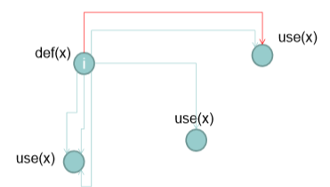
- All-uses coverage: For each node i in the CFG that contains a definition to variable x, it requires that for every use of x in the CFG, the test suite covers at least one feasible du-path of x that starts from i and ends at that use of x.
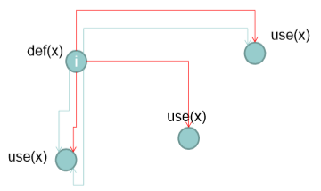
- All-du-paths coverage: For each node i in the CFG that contains a definition to variable x, the all-du-paths coverage requires that for every use of x in the CFG, the test suite covers all feasible du-path of x that starts from i and ends at that use of x.
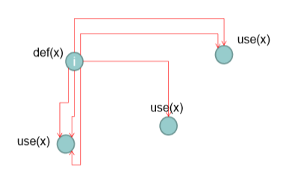
- Interface coverage
- Occurs at the interface of the code units.
- Coverage for interaction between code units.
- Includes:
- Function/call coverage
- Inter-procedural dataflow coverage
- Object-oriented coverage
- Function/call coverage
- call graph:
- Nodes: functions(or methods)
- Edges: calls to functions(call-site)
- Functional coverage: cover every function at least once (every node in the call graph)
- Call coverage: cover every call-site at least once (every edge in the call graph)
- Complexity in function/call coverage:
- Function overloading: static binding issue, invoke which overloading function at the call-site?
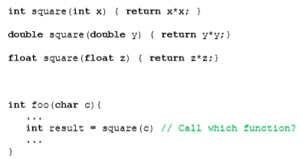
- Function pointer: dynamic binding issue, cover every possible function instance at the function-pointer call-site.
- Polymorphism (多态): dynamic biding issue, cover every possible method instance at the virtual-method call-site.
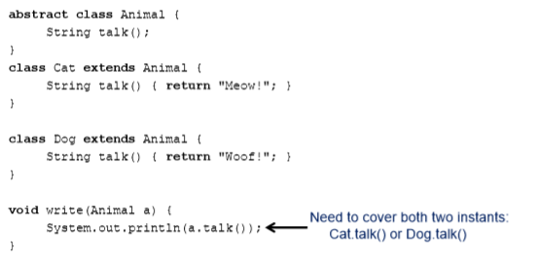
- Inter-procedural dataflow coverage
- Data flow across units are more complicated than data flow within units.
- Some definitions:
- Caller: a unit that invokes another unit.
- Callee: the unit that is called.
- Call-site: statement or node where the call appears.
- Actual-parameter: expression in the caller.
- Formal-parameter: variable in the callee.
- Last-def and first-use
- Last-def: the definition that has at least one def-clear path from this definition to the call-site.
- First-use: the use that has at least one def-clear and use-clear path from the call-site to this use.
- What is inter-procedural dataflow coverage:
- For each node i that contains a last-def to variable x, the all-inter-procedural-def coverage requires that the test suite covers at least one feasible du-path of x that starts from i and ends at any of the first-use of x in the immediate caller/callee.
- For each node i that contains a last-def to variable x, all inter-procedural-use coverage requires that for every first-use of x in the immediate caller/callee, the test suite covers at least one feasible du-path of x that starts from i and ends at that first-use of x
- Object-oriented coverage
- OO design: emphasis on modularity.
Design units: classes, interfaces, methods.
- OO coverage: cover connections between design units.
- Typical OO aspects:
- Inheritance: method overriding, variables shadowing, constructors overriding works differently.
- Polymorphism
- In addition to object level members, there are class level members.
- Coverage on inheritance graph: create an object for each class and apply call coverage.
- OO method coverage: for each method, call it with objects of all possible classes.
- OO call method: for each method, call it with objects of all possible classes at all possible call-sites.
- Mutation coverage
- Mutant: a program with a seeded fault
- Mutation coverage = D/N D = number of killed mutants N = total number of mutants
- Mutation testing: use mutant coverage as the test adequacy criteria to design the test suite.
- Why mutation coverage?
The strongest coverage criterion and subsumes all the coverage criteria we have learned.
- Complexity in mutation testing
- Scalability: too many mutants.
- Equivalent mutant: a mutant that is semantically equivalent to the original program.

Part Ⅱ Problems-3 Test Adequacy(Blackbox, level-1)
- Whitebox approach to test adequacy: the test suite is considered adequate if every concerned code element is covered by at least one test case.
- Balckbox approach to test adequacy: the test suite is considered adequate if it covers representative choices of input to the unit-under-test.
- Covering the representative choices of input:
- Level-1: single input parameter - cover the representative choices for one single input parameter.
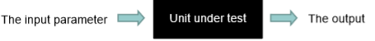
- Level-2: combination of input parameters - cover the representative combinations of multiple parameters.
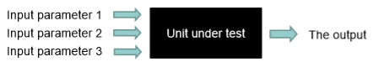
- Level-3: sequence of parameter combinations - cover the representative sequences of parameter combinations.
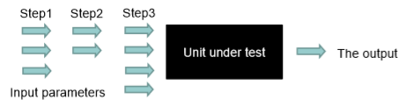
- Level-1 techniques
- Equivalence class partitioning (ECP, 等价类划分)
- Partition the input domain of the parameter into equivalence classes.
- Adequacy criterion: cover each partition at least once.
- Boundary value analysis (BVA, 边界值分析)
- Analyze the boundary cases for each equivalence classes in ECP.
- Adequacy criterion: cover each boundary case at least once.
- Cause-effect graph and decision table(因果图和决策表)
- Analyze the causal relation between input and output as edges.
- Adequacy criterion: cover each edge at least once.
- Equivalence class partitioning: partition the input domain into equivalence class.
- A set of input domain values can be considered to be an equivalence class if they can reasonably be expected to cause similar responses from the program.
- Consider both valid classes and invalid classes.
- Cover each equivalence class by choosing a representative value of each class.
- Partitioning: a partitioning of a set A is to divide A into subsets a₁, a₂,..., a_{n} such that:
- Completeness: a₁∪a₂∪...∪a_{n} = A
- Disjoint: For any i and j, a_{i}∩a_{j}=Ø
- Rule to partition an input domain: group inputs that cause similar responses from the program as described in the requirement.
- How to find classes
- If the parameter shall be within a range [a, b]
- Within range [a, b]: a valid class
- Too large [b, +∞]: an invalid class
- Too small[-∞, a]: an invalid class
- If the parameter shall be one in a set of values
- One valid equivalence class for each value in the enumeration.
- One invalid equivalence class: all values not in the set.
- If the parameter shall satisfy some conditions
- One valid class for satisfying the conditions.
- One invalid class for violating each condition.
- The parameter shall be a list of values
- Create one valid class for the correct number of values.
- Create two invalid classes, one for fewer values and one more values.
- Additional classes: might not be in the requirement, but still necessary to test.
- Empty: value exists, but has no contents.
E.g. Empty string “”, empty set, empty list
- Blank: values exists, and has content.
E.g. String that contains “ ” only
- Null: value does not exist or is not allocated.
E.g. Null reference, null pointer
- None:does not provide value for the parameter, or when the parameter require selecting one item from a list, make no selection.
- Very long: the length of the the input is extremely long.
- Special value: February
- Encoding of string: utf-8 vs. GBK
- Complexity in ECP
- Invalid partitioning: the classes have overlapping part, or they do not cover the whole input domain.
- Partitioning that is too coarse:some classes shall have been further partitioned.
- Boundary value analysis
- Motivation: most errors are caught at the boundary of the equivalence classes.
- An extension and refinement of ECP.
- Given the equivalence of parameter P, BVA requires that for each boundary classes, cover:
- The boundary
- Just above the boundary by one min_unit
- Just below the boundary by one min_unit
- The test cases in BVA is redundant in ECP, but necessary to enhance ECP.
- How to find boundary cases:
- If the parameter shall be within a range,[x, y] or (x, y)
- Valid: x and y
- Invalid: just below x (e.g. x-min_unit)
- Invalid: just above y (e.g y+min_unit)
- If the parameter is one from a list of values
- Valid: min and max
- Invalid: just below min (e.g. min-min_unit)
- Invalid: just above max (e.g max+min_unit)
- If the parameter is a data structure
Define test data to exercise the data structure at the prescribed boundaries.
- BVA is not applicable for data with no meaningful boundary.
- Cause-effect graph and decision table
- Motivation:
- Problem 1: ECP requires the partition of the input parameters, but how do we know the ways?
- Problem 2: when the input is subject to complicated conditions and their combinations, how do we design the equivalence classes?
- The idea: partition the input domain by how the program responds to different input conditions.
- Cause-effect graph: models dependency between program input conditions (known as causes) and output condition (known as effects).
- Cause: any condition in the requirements that may affect the program output.
- Effect: the response of the program to some combination of input conditions.
- Notations:
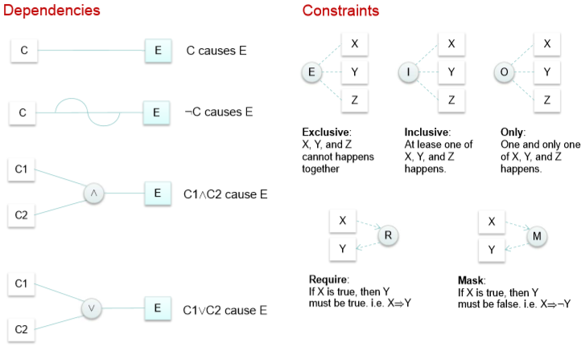
- Coverage for cause-effect graph
- For each effect, cover its true and false case at least once.
- For each ‘∧’ node with n coming values n₁, n₂, ..., n_{k}, cover k+1 cases:
- All true
- All but n_{m} true
- For each ‘∨’ node with n coming values n₁, n₂, ..., n_{k}, cover k+1 cases:
- All fasle
- All but n_{m} false
- Decision table: a tool to plan the test cases for covering cause-effect graph.
- The upper parts of decision table: shows the causes.
- The lower parts of decision table: shows the effects.
- Each column represents one equivalence class for the input parameter.
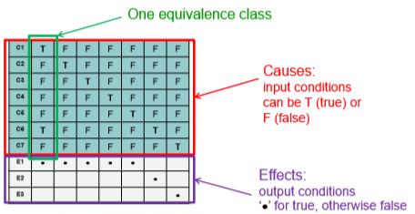
- Finding cause-effect adequate test cases
- Generate a decision table from a cause-effect graph to achieve cause-effect coverage.
- Input: a cause-effect graph with N causes and M effects, and their associated constraints.
- Output: a decision table DT with N+M rows and W columns, where W depends on the cause-effect graph.
- Initialize an empty decision table.
- For each of the effects Ej
- Starting from Ei, trace back through the graph, for each encountered node:
- A ‘∨’ node with k precedents: find k+1 combinations of causes that cover the ‘k+1’ cases.
- A ‘∧’ node with k precedents: find k+1 combinations of causes that cover the ‘k+1’ cases.
- The node has been covered in previous iteration: ignore this node.
- Create a column in the decision table for each combination of cause. For causes not covered in the combination, freely set the as true/false as long as the constraints are satisfied.
- If the true/false loop value of an effect is not covered in the above loop, find a combination of causes to combine it and create a column in the decision table.
- Merge redundant columns in the decision table.

Part Ⅱ Problems-3 Test Adequacy(Blackbox, level-2)
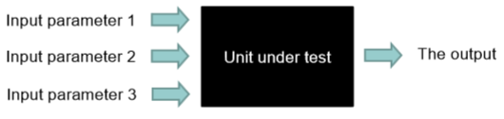
- Why combination: many faults are triggered by interaction between input parameters of the unit under test.
- Level-2 techniques:
- Combinatorial coverage(组合覆盖): cover each t-way interaction at least once.
- Constrained combinatorial coverage(带约束的组合覆盖): combinatorial coverage subject to additional constraints between parameters.
- Combinatorial coverage definition:
- Let p be the number of parameters: parameters are indexed 1, 2, ..., p.
- For each parameter i, suppose there are n_{i} concerned values. These values are from the n_{i} equivalence classes & boundary cases of this parameter.
- t-way interactions between parameters i, i+1, i+t-1: the n_{i}*n_{i+1}*...n_{i+t-1} value combinations.
Assumption: parameters are independent. That is, the choice of values of any parameters does not affect the choice of values for any other parameter.
- t-wise (combinatorial) coverage: cover all the t-way interactions between any set of t parameters.
Special case: pairwise (combinatorial) coverage -- covering all two-way interactions.
- The number of test cases required to cover all t-way interactions grows exponentially with t.
- How to cover all two-way interactions with the fewest number of test cases?
- Transform the problem: minimize x₁+x₂+...+x₈, x∈{0, 1}. A greedy algorithm is usually good enough.
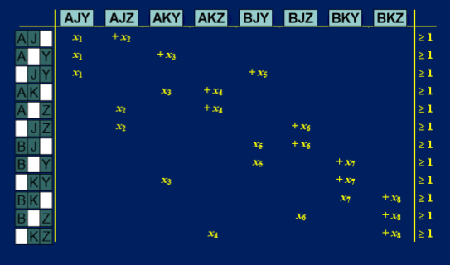
- Greedy algorithm:
- Input:n parameters with different values.
- Output: k combinations of the values that achieve two-way interactions.
- Initialize the result set as empty.
- For each parameter x_{i}, if the interaction has been covered by one of the combinations in the result set, ignore it. Otherwise, create a combination that covers this interaction and the most amount of interactions not yest covered.
- Return the result set.
- Constrained combinatorial coverage
- Why constraints?
- Rule out unfeasible combinations.
  - They are impossible to input through user interface.
  - Need to differentiate unfeasible from invalid.
- Rule out redundant combinations-some values of one parameter might trigger the system to bypass whatever values the other parameters take.
- Types of constraints:
- Property constraints: rule out unfeasible combinations.
  - Typically expressed using first-order logic.
- Error/single constraints: rule out redundant combinations.
  - Usually expressed as a label on a value or a class of the parameter.
  - It means that we need only one of the combinations that covers this value/class, regardless of interaction strength.

Part Ⅱ Problems-3 Test Adequacy(Blackbox, level-3)
- Level-1 vs. Level-2
- Similarities:
- Address the same problem: inputs are subject to complex conditions.
- Cause-effect graph considers the combinations of conditions, while category-partition testing considers the combinations of choices.
- Both use constraints to rule out unfeasible combinations.
- Differences:
- Cause-effect graph use cause-effect relation to rule out redundant combinations while category-partition testing use property constraints.
- Category-partition testing tries to cover all unfeasible combinations while cause-effect graph does not require covering all combinations.
- Many faults are triggered by the order of input events.
- Sequence coverage for simple event: extension of combinatorial coverage
- Sequence Covering Array Properties: for any t, number of test cases required to cover all t-ways sequences grows with log(n), for n events.
- Challenges of GUI Testing:
- Complex event, many sequences.
- Complex dependencies between events.
- Unsolicited events may occur at any time.
- Testing unsolicited events is difficult.
- Multiple ways to achieve the same result.
- Multiple ways of selecting options.
- Should the feature be tested 3 times over?
- Need a model of GUI:
- From a programmer’s perspective:
- GUI object library: a library with pre-defined GUI objects, each with a pre-defined set of properties, methods and events.
  - Containment hierarchy
  - Inheritance hierarchy
- Event-driven execution model
  - Order of execution is governed by user.
  - Program responds to events generated by user interaction with GUI objects.
  - Developers write event handlers to implement the application.
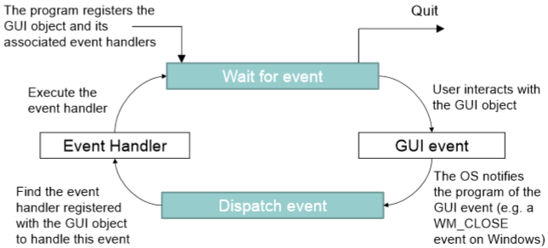
- From tester’s perspective:
- Three points of view on a GUI program:
  - A set of code units
  - A set of events
  - A set of features
- The first view: use previous whitebox coverage criteria.
- The latter two view: lead to two new sets of blacbox criteria dedicated to GUI testing.
- Level-3 coverage criteria
- Event-based coverage(GUI program = a set of events)
- State-based coverage(GUI program = a set of features)
- GUI state is modeled using:
- GUI objects O = {o₁, o₂, o₃, ..., o_{m}}
- Properties P = {p₁, p₂, p₃, ..., p_{i}}, where pi is an ni-ary Boolean relation of the form:
Property(o₁, o₂, o₃, ..., o_{k}, value)
- GUI state: S = {p₁, p₂, p₃, ..., p_{n}}
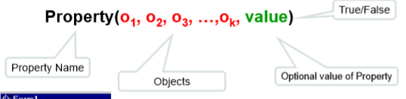
- GUI events:
- Events change the GUI’s state.
- Events E = {e1, e2, e3, …, en}, associated with a GUI are functions from one GUI state Si to another state Sj.
- Notation: Sj = e_{i}(Si)
- Model the GUI events using event operators, which specify their preconditions and effects.
- (Event) operators:
- A triple: <Name, Precondition, Effects>
- Name: identifies an operator and its parameters.
- Precondition: a set of literals.
- Effects: a set of positive or negative literals.
- Operator Op is applicable in any state S_{i} in which all precondition(Op) are TRUE.
- The resulting Sj is determined by using effects(Op)
- All positive literal in effects(Op) ), and
- All literals that were TRUE in Si, except
- Those that are negative in Effects(Op)
- Event e_{x} follows e_{y} iff e_{x} can performed immediately after e_{y}.
- Event-flow graph: A 4-tuple: <V, E, B, I>
- V: the set of verticals, representing events.
- E: the set of directed edges, showing the follows relationship.
- B: the subset of events first available(shown in red).
- I: the subset of events that invoke other windows(dotted lines).
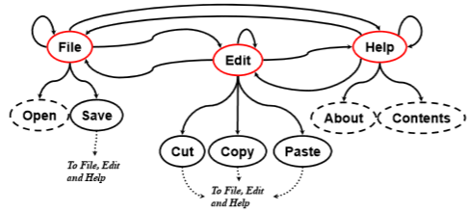
- Legal event sequence: e₁, e₂, ..., e_{n} is a legal event sequence:
- If (e_{i}, e_{i+1}) is an edge in an event-flow graph.
- Or e_{i} invokes component C_{x} and e_{i+1} is an event in C_{x}.
- GUI test case:
(S0, e1;e2;e3;…;en, S1; S2;… ;Sn)
- S0 is a GUI state, and
- e1;e2;e3;…;en is a legal event sequence
- Si= ei(Si-1), 1 <= i<= n
- Coverage criteria:
- Each windows is a unit of testing.
- Intra-window coverage criteria-test events within each window.
- Cover every node in the event-flow graph.
- Each event in the window should be performed at least once.
- Inter-window coverage criteria-test events across components.
- Concern the event flow between windows.
- Invocation coverage
  - Invoke each window
  - Cover each restricted-focus event
- Invocation-termination coverage
  - Invoke each window and terminate it
  - Cover restricted-focus event followed by a termination event
- Inter-window length-n coverage: cover sequences that start with an event in one window and end with an event in another window.
- Integration tree: a triple <N, R, B>
- N: the set of windows in the GUI.
- R: a designated window called the Main window.
- B: the set of directed edges showing the invokes relation between windows.
- Design adequate GUI test cases:
- Step 1: enumerate all windows of the program and build the window hierarchy.
- Step 2: for each window, identify the events that can occur and describe them with operators.
- Step 3: design test cases to cover every representative events.
- Generate representative events from the set of operators and design test cases to cover each of them.
- For each event:
  - First satisfies its precondition.
  - Then satisfies its choices.
  - Check the expected results.
- Step 4: identify the “follow” relation between events and build the event flow graph.
- Step 5: design test cases to cover intra-window event interactions.
- Step 6: design test cases to cover inter-window event interactions.
- When identifying operators, we need to make several decisions:
- How to partition each parameter?
-- general rules:
- Adding additional choices if we know from experience they require special treatment in the implementation.
- Choices for boundary cases are usually necessary.
- Parameterization or not?
-- general rules:
- If two parameters have similar parameters, preconditions, and effects, consider joining them into one operator, with one or more additional parameters separating them.
- If such a parameterization results in complex constraint, don’t do it.
- Abstraction or not?
-- general rules:
- If you do not plan to achieve inter-window event interaction coverage (which can be costly), always abstract the dialog into an operator if it is possible.
- If the dialog is simple, prefer abstraction.
- Aggregation or not?
-- general rules:
- If some events are unlikely to trigger some errors (such as open menu/sub-menu),
- or the program does not handle them at all (such as pressing the keys in the edit control)
- Then we can aggregate them into the events that follow them.
- A systematic way to discover all operators:
- Explore all menu items(main or right-click menu).
- Explore all buttons.
- Explore the manual and requirement documents.
- Use a GUIRipper(automatic, but not reliable).
- Cover intra-window interactions:
- The strength of interaction is limited to two.
- Cover the three possible “follows” relation: always, never and conditional.
- Cover inter-window interactions:
- Inter-window length-n coverage: cover sequence that start with an event in one window end with an event in another window.
- Typically, n = 3: one event in the first window, followed by the invocation event, followed by one event in the second window.
- Two typical types of invocation:
- Open a modal dialog.
- Switch to another MDI(多文档界面) window.
- Features of a GUI program: an end-effect that the user of a GUI wants to achieve.
- Scenario: sequence of events carried out by a user to use a desired feature.
- A feature can have multiple(possible infinite) scenarios.
- A scenario x might overlap with another scenario y, or be fully contained by y, or simply share GUI objects with y.
- Finite state machine: constructed for each feature to capture all scenarios of this feature.
- State: intermediate states of the GUI windows.
- Transitions: events between states that users trigger.
- State-based coverage:
- Generate from the FSM a minimal set of event sequences that:
- Cover every state
- Cover every transition

Part II Problem-6 Test Automation
- Test automation is the process of writing a computer program to do testing that would otherwise need to be done manually.
- Test automation process:
- Design test cases.
- Detect the opportunity to automate test execution.
- Select the appropriate tool to develop the test automation program.
- Debug test automation program.
- Integrate the test automation program with test automation program with test management tool.
- Run the test automation program.
- Get the result.
- Test automation program includes:
- Test driver
- Drive test execution and implement test oracle.
- Consist of test engine and test scripts when using test automation tool.
- Test stub: substitute for functions/methods/objects/components/lib ray that the code under test depends on.
- Test harness: substitute for other parts of the deployed environment.
- Automation opportunity:
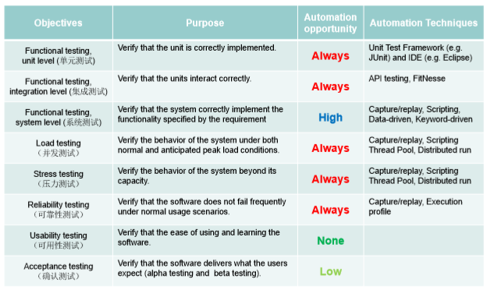
- Test automation: “IS” and “IS NOT”:
- Test automation is software development.
- Test automation is long time investment.
- Test automation is not silver bullet for testing.
- Test automation is not always recommended.
- Test automation is not complete replacement of manual testing.
- When is automation recommended?
- The benefits of test automation need to be greater than the cost of automation.
- It is expected that tests will have to be run many times.
- Factors that affect cost:
- Controllability: can the test automation program easily control the program execution?
- Observability: can the test automation program easily observe the output of the program?
- Improve controllability and observability
- Apply separation of concerns in the design: separate application from GUI.
- Simulation of external dependencies with test stub and test harness.
- Implement configuration options to trigger corner cases.
- Use assertions: expose internal state errors.
- Make program failures obvious.
- Keep the output simple and well formatted.
- Log failures to a separate file.
- Test automation techniques:
- Capture/Replay
- Structural test scripts development
- Data-driven test automation
- Keyword-driven test automation
- Test scripts: simulate the operations on the system under test by the users or another system.
- Key issues in test scripts:
- Identification of GUI objects: how can we know the button we found during script replay is the same one when recording this script?
- Simple way: find-by-attribute
  - Finding objects by matching the values of their properties.
  - Put the attribute names and values directly into the test script.
- More general way: object map
  - An intermediate layer that maps each GUI object identifier to a descriptor.
  - Kept in a separated file.
  - Find-by-attribute is a special case.
  - Descriptor types:
    - Weighted multiple properties: put different ‘weights’ to the properties.
      - Exact match:
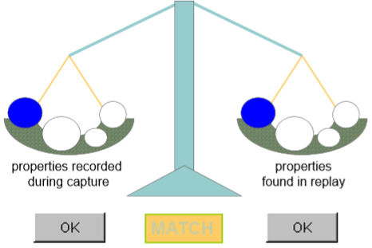
      - Close-enough match:
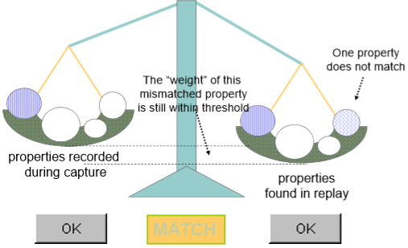
      - Too many differences: object not found.
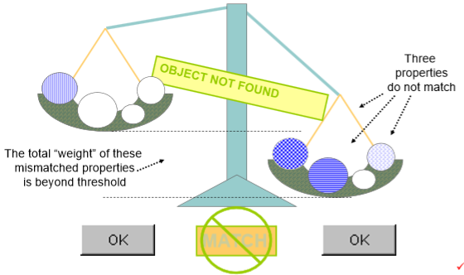
    - Indexing: give each GUI object an index based on its relation with the other GUI objects in the same window.
      - Creation-order: the order in which the GUI object is created in the window relative to other objects in the same window.
      - Location-order: indicates the order in which the GUI object is shown within the window relative to other objects.
    - Patterns:
      - Regular expression: matches the values of string properties.
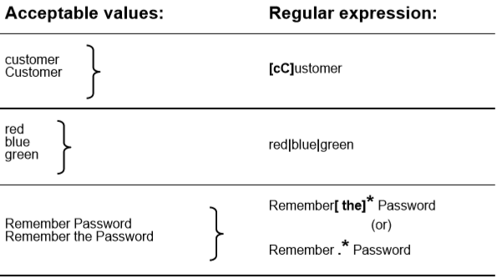
      - Numeric range: specifies a range of numeric values to match number properties.
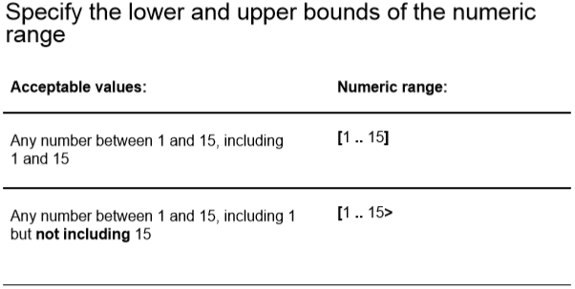
    - Virtual objects
- Test oracle: how to check expected output?
- Checkpoint: a point in a script that inserted to check the state of the system.
  - Record a verification point wherever you need to verify expected results.
  - Common types of checkpoint:
    - Property checkpoint: check whether the properties of a GUI object are equal to specific values.
    - Image checkpoint
    - Table checkpoint: check the values of cells in an application.
    - Database checkpoint: compares the dynamic values in the application with the values from the database.
- Cons and pros of capture/replay
- Pros:
- Conceptually simple.
- Straightforward.
  - Don’t need coding.
  - Don’t need to understand test script language.
- Cons:
- Low fault detection capability.
- Interface changes force maintenance of tests.
- Cannot apply until the product is stabilized.
  - Too late to find bug.
  - Cannot get timely feedback from users.
- Structural test scripts developments
- Idea: test script development with structured programming constructs.
- Use control statements and module design to improve the robustness of test scripts and enable code reuse.
- No modular design:
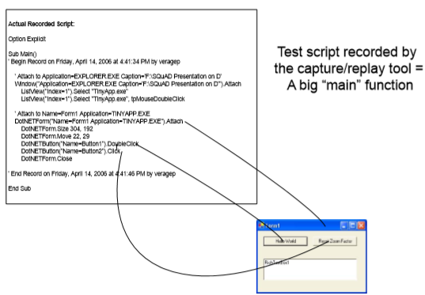
- Modular design:
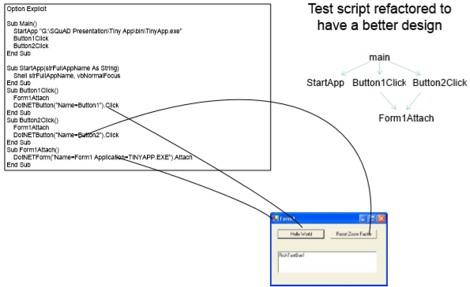
- Data-driven test automation
- Idea: Data is defined in external data source and de-coupled from test script.
- Similar business process, different data. One test script to implement multiple test cases.
- Test design is driven by tables of input data and expected output.
- Keyword-driven test automation
- Idea: known as action-word testing, center around the concept of keywords.
- Three steps:
- Domain experts and test engineers work together to identify operations that can be modeled as keywords.
- Test engineers implement the keywords.
- Domain experts design test cases with the keywords.
- Benefits:
- Better utilization of expertise.
- Domain experts as end-users of the software get involved in testing earlier.
- Test case design activity can be started earlier.
- Test scripts are much easier to understand and maintain.
- Types of keyword:
- Low-level keywords
  - Keyword functions are implemented as operations on GUI objects.
  - Defined by the object map automatically. No efforts required from the test engineers.
  - Deeply coupled with the GUI. Not available before the GUI is stabilized.
- High-level keywords
  - Keyword functions are implemented as functions in script languages.
  - Defined by test engineers. Significant efforts required.
  - Function interfaces provide a level of abstraction. Domain experts can start their work earlier.
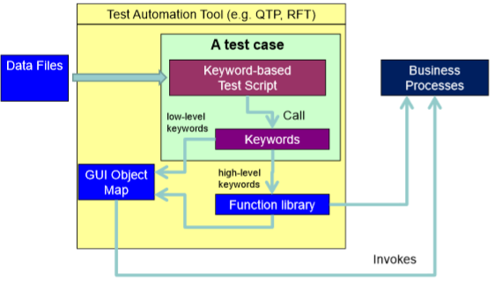
- Maintenance of test cases: keeping changes in system functionality coordinated with the test suite.
- Preventive maintenance: test suite “clean-up”
- Removing tests that are no longer relevant.
- Accumulation of duplicate/redundant tests.
- Removal or refactoring of unreliable tests.
- Ensure success of TA:
- Evaluate an automated tool: Choose a tool that fits your business requirements & technical expertise.
- Plan:
- Establish goals & objectives.
- Be ready to have quality metrics to validate the return of investments.
- Design:
- Keep in mind the user community of TA system.
- Choose an architecture that reduces maintenance and is extensible.
- Implement:
- Practice OOD principles of reusability & modularity.
- Introduce version control of your code.
- Establish code review process.
- Test & Maintain
- Unit test your code.
- Constantly re-evaluate reasons for maintenance and improve TA architecture to minimize maintenance.

Part II Problem-7 Test Management
- Test management is the activity of managing the test project.
- Test process: the process which defines procedures and activities required to successfully complete the testing a project.
- Understanding test process:
- What: what are the main activities.
- Divided by levels:
  - Unit testing(component testing)
    - Testing at the code module level.
    - Typically performed by developers exclusively.
  - Integration testing
    - Testing to assure that the code modules and groups of code modules work correctly with each other.
    - Lower, module-to-module level is typically performed by developers.
    - Higher, subsystem-to-subsystem level is typically performed by test engineers.
  - System testing
    - Testing of the whole system outside of the production environment.
    - Typically performed by test engineers.
  - Acceptance testing
    - Testing to verify that the system meets the user’s requirement.
    - “Alpha testing”: performed by the users in the development environment.
    - “Beta testing”: performed by the users in the customer environment.
- Divided by phases: planning, design, execution, analysis
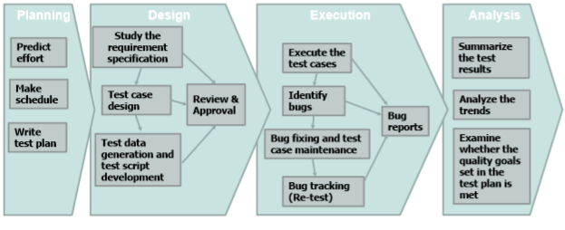
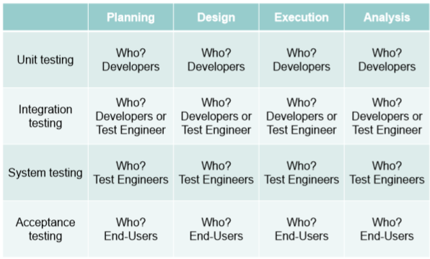
- When: when is each activity carried out.
- Testing activities are carried out in software development lifecycle.
- About software development lifecycle
  - Definition: the process used to create a software product from its initial conception to its public release is know as the software development lifecycle model.
  - Four frequently used models:
    - Code-and-Fix
      - The product is implemented without requirements or specifications, or any attempt at design.
      - Simply throw code together and rework it as many times as necessary to satisfy the client.
      - Used in small project and not scalable to serious software products of any reasonable size.
    - Waterfall
      - A linear life-cycle model.
      - Benefits:
- Formal, standard, specific phases with clear goals.
- Clear divisions between phases.
- Good feedback loops between adjacent phases.
      - Drawbacks:
- Assumes requirements will be clear and well understood.
- Requires a lot of planning up front.
- Rigid, linear, not adaptable to change in the product.
- Costly to “swim upstream” back to a previous phase.
- Nothing to show until almost done.
- Testing in waterfall model:
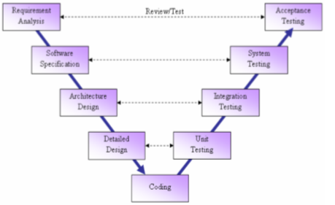
- When to carry out activities:
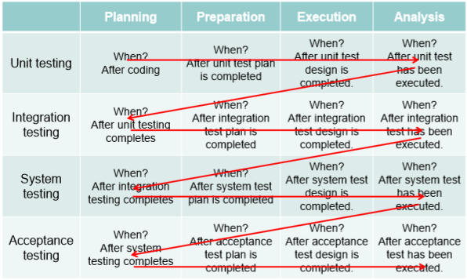
- Pros: test engineers know exactly what the software is expected to do, so that there is no question about whether something is a feature or a bug.
- Cons: too late to find a bug.
    - Spiral
      - Steps taken at each loop:
        - Determine objectives.
        - Identify and resolve risks.
        - Development and test.
        - Plan the next iteration.
      - Benefits:
        - Provides early indication of unforeseen problems.
        - Always addresses the biggest risk first.
        - Accommodates changes, growth.
        - Eliminate errors and unattractive choices early.
      - Drawbacks:
        - Relies on developers to have risk-assessment expertise.
        - Over-focuses on risk and “putting out fires”, other features may go ignored because they are not “risky” enough.
- The test result of the present iteration will help identifying and resolve risks at the next iteration.
    - Agile
      - Characteristics:
        - Light weighted methodology.
        - Small to medium sized teams.
        - Vague and/or changing requirements and techniques.
        - Simple design.
        - Minimal system into production.
- Who: who carry out each activity.
- How: how is each activity done.

Part II Problem-8 Test Generation
- Challenges of test generation
- Theoretically difficult.
- The relation between the selection of test data and the satisfaction of test data and the satisfaction of test adequacy criteria is indirect.
- Test input data is subject to complex structure and constraints.
- Test generation techniques
- Whitebox(based on source code)
Given: a code unit as the target to cover
Goal: find program input data on which the target is executed
- Symbolic test generation(基于符号执行)
- Concolic test generation(基于协同执行)
- Blackbox(based on specification)
- Random test generation(随机生成)
- Constraint based test generation(基于约束)
- Evolutionary test generation(遗传算法)
- Grammar-based test generation(基于语法)
- Whitebox(based on source code)
Given: a code unit as the target to cover
Goal: find program input data on which the target is executed
- Fundamental problem: path coverage.
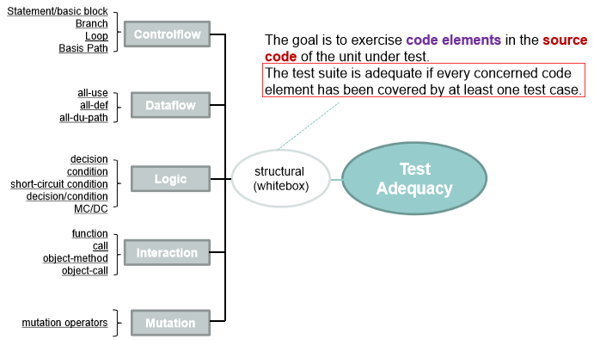
All of them can be specified as a set of path to cover.
- Symbolic test generation
- Goal: generate test data to cover a specific path.
- Method: generate a set of path constraints C for a given path p such that any test data that satisfy C will cover the path p.
- How to language features:
  - Loop: add the loop condition as path condition for every iteration.
  - Exception: add the exception condition as the path condition.
  - Function call: use their symbolic output to represent the return value.
- Generating test data:Using a constraint solver:
  - Input: constraints such as x+1<y and y-(x+1)>-1
  - Output: values that satisfy the constraints, or a conclusion that the constraints are unsatisfiable.
  - Constraint solving is a hard problem.
- Concolic test generation
- Idea: combine concrete and symbolic execution.
- Refer to ppt for an exact example.
- Blackbox(based on specification)
- Random test generation(随机生成)
- Idea:
  - For each parameter, generate a random but legal value.
  - Apply the random values for all parameters to the system under test.
  - Check the result and then go back to step 1.
- Systematic random testing can be very effective.
Theoretical work suggests that random testing is as effective as more systematic input generation techniques.
- Key issue: how to enumerate the valid input space.
  - Approach 1: first generate all possible input without considering validity constraints, then rule out invalid ones.
  - Approach 2: start from a valid input, then apply all possible sequence of valid operations on the starting simple valid input..
- Method sequences:
  - A sequence of method calls.
  - Each call in the sequence includes a method name and input arguments, which can be
    - Primitive values such as 0, true, null
    - Objects returned by previous calls
    - The receiver of the method call is treated as the first argument of the method call.
- Constraint based test generation(基于约束)
- Evolutionary test generation(遗传算法)
- Using genetic algorithm to get the solution.
- Genetic algorithm: simulate evolution
  - Maintain a population of solution candidates as individuals.
  - each individual is evaluated by its fitness.
  - Each individual are crossovered or mutated to get offspring individuals.
  - Repeat 1-3 until a satisfactory individual is found.
- Grammar-based test generation(基于语法)
Idea: Use context grammar to describe the structure of valid input.

